Pass Task 3.1 Wikis and design documents

Contributions to wiki page:

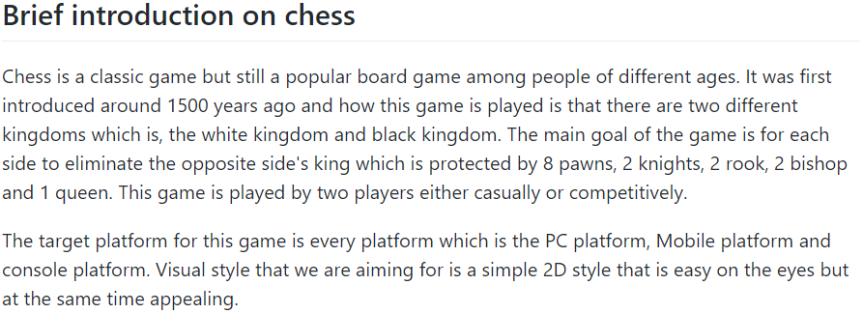

I oversaw doing the brief introduction to our game’s wiki page like what is it about, the history, and what platform are we aiming to release this game on.

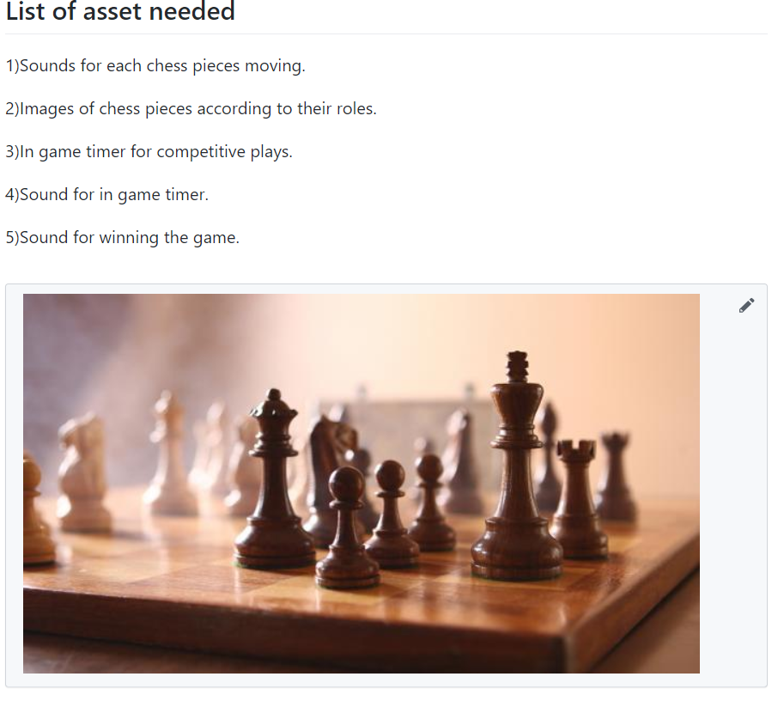

I also oversaw listing down the assets needed for the game and the footer of the wiki page.